 |  | 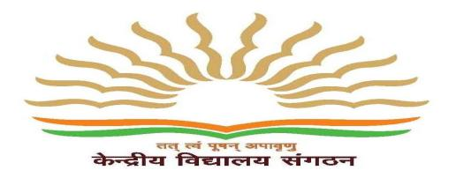
पीएम श्री केंद्रिय विद्यालय  तिबरी छावनी, गुरदासपुर,  पंजाब – 143530  शिक्षा मंत्रालय,  भारत सरकार केअधीन | PM SHRI KENDRIYA VIDYALAYA  TibriCantt., Gurdaspur,  Punjab - 143530  Under Ministry of Education,  Govt. of India  E-Mail:kvtibrigsp@gmail.com  Website: https://tibricantt.kvs.ac.in/

F- 26/1667/PMSGSP/APAR/2023-24/ Dated: 30.03.2024
CIRCULAR FOR KV/TC ADMISSIONS
Following documents are to be submitted at the time of admission along with the application form duly signed by Parents by those who are seeking admission on KV/TC basis:
- Application form (to be taken from the office):
- KV/ TC : Ensure that it has been uploaded on the website by the previous Vidyalaya of the child
- Movement order copy
- Service certificate cum quarter allotment (Residence) certificate (in Original).
- Aadhar card copy of the child and the Parents
- Report card of the present/ previous class
- CBSE registration Card (in case of admission in class 9 or above)
- Permanent Education Number (from the UDISE portal of the prev Vidyalaya)
- Blood Group report
Timing for Parents seeking admission on KV/TC basis- 1:00 pm- 2:00pm in Chemistry lab
Note: For any other inquiry or those seeking fresh admission can meet the Helpdesk members viz.,
FOR ADMISSION TO CLASSES 1 TO 5
- Ms. Harshita, PRT
- Ms. Poonam, PRT
FOR ADMISSION TO CLASSES 6 TO 9
- Ms. Meenu, TGT
- Mr Manoj, TGT

Admission I/C PRINCIPAL

